S&P 500 Stock Prices

Historical data for the S&P 500 companies' stock market performance between 2014 and 2017 is available. Each entry in the dataset corresponds to a single trading day and contains information such as the company's ticker symbol, trading volume, highest and lowest stock prices during the day, as well as the opening and closing prices.

# Recommended Analysis

## Create a line graph to analyze the trend in trading volume(Using Date Hierarchy)

Initially, the automatic date hierarchy feature was disabled in the options. Subsequently, time markers such as the beginning of the year, quarter, month, week, and day were incorporated into the stock prices table in Power Query. A calculated measure named "Total Volume" was formulated using the expression: Total Volume = SUM('Stock Prices'[volume]). Lastly, the graph was constructed following the visual representation provided with drill up and drill down options.

## Display the stocks that exhibit the highest trading volumes

I set up a matrix in which I assigned symbols to the rows and placed the Total Volume measure in the values section. To identify the top ten symbols with the greatest volume, I employed the Top N technique for filtering.

## Selecting a stock to invest in between January 2, 2014, and December 29, 2017, and calculating the percentage gain achievable

The task involves determining the "low price" of stocks on January 2, 2014, and the "high price" on December 29, 2017. This is followed by subtracting the low price from the high price and then dividing the outcome by the low price to obtain the potential profit as a percentage. To achieve this, I established a "Low Price (1/2/2014)" measure which employs the MINX function to locate the lowest prices specifically on January 2, 2014. Similarly, a "High Price (12/19/2017)" measure was created, utilizing the MAXX function to identify the highest prices only on December 29, 2017.

Furthermore, a "Profit (%)" measure was established in percentage format. This measure calculates the profit percentage, taking into consideration cases where the denominator might be zero. For the presentation of results, a matrix was devised. Symbols were allocated to the rows and the "Profit (%)" measure was assigned to the values section. The application of TOP N filtering facilitated the display of the top 10 stocks with the highest profit potential.

## Generate a card that presents the stock with the highest depreciation within the same timeline mentioned earlier

To start, I formulated a metric known as "Neg Profit (%)," achieved by multiplying the "Profit" measure by negative one.

Next, I applied symbols to a card and used a Top N filter to identify the stock with the highest depreciation.

Afterward, I added another card to the visualization, featuring the "Profit (%)" measure. Using the Top N filter with symbols, I highlighted the stock with the most substantial percentage decline.

## When examining Amazon's stock (AMZN), which date exhibited the highest volatility, measured by the variance between the high and low prices?

I established the "Max Volatility (AMZN)" measure, which is tailored to Amazon (AMZN) stock by filtering for it. This measure calculates the highest volatility in terms of percentage by iterating through the relevant rows in the 'Stock Prices' table. It computes the difference between the high and low prices for each day and divides it by the high price.

Subsequently, I crafted a Multi-row card that initially displays the date and then the corresponding volatility percentage. To facilitate this, I implemented a TOP N filter based on the values of the "Max Volatility" measure, ensuring that the dates with the highest volatility percentages are shown.

## Which date in the sample saw the largest overall trading volume? On that date, which two stocks were traded most?

To begin, I generated a card displaying the highest daily volume observed within the 2014-2017 period for S&P 500 stocks. I achieved this by utilizing the "Total Volume" measure and implementing a Top N filter on the date column, based on the values of the "Total Volume" measure.

Next, I established an additional card that presents the specific date when the highest daily volume occurred. To accomplish this, I devised a straightforward "Date" measure by aggregating the date column using the MIN function. This approach was chosen to avoid relying on implicit measures and to maintain transparency in the calculations. Then I applied same Top N filtering above.

Lastly I created a card that shows most traded 2 stocks on that day. In order to achieve this I created “Most Traded 2 Stocks by Daily Volume” measure given in image.

This DAX code calculates the symbols and volumes of the top 2 most traded stocks based on their daily volume in descending order, and then concatenates them into a single text string for display. Upon utilizing this measure within a card visualization and applying the identical filtering criteria mentioned earlier, the resultant card was produced.

## On which day of the week does volume tend to be highest?

I began by aggregating the data in the 'Stock Prices' table, grouping it by date, start of week and calculating the total volume for each day. This resulted in a new table called “Volume by Day”. Subsequently, I derived two additional columns, "year" and "week of name," from the existing date column from “Volume by Day” table. These columns were established to facilitate subsequent analysis. Later, I crafted another table that grouped data by the "start of week" column, calculating the maximum sum of volume by day for each week. This new table is called “Max Volume in the Week”.

I established a one-to-one cardinality relationship connecting the "Max Volume" column in the "Max Volume in the Week" table with the "Sum of Volume by Day" column in the "Volume by Day" table. Additionally, I implemented a many-to-one cardinality relationship between the dates in the original table (stock prices) and the dates in the "Volume by Day" table.

Subsequently, I generated a year slicer using the "year" column present in the "Volume by Day" table. This was done to ensure seamless interaction across required elements on the page, as the "Year" column from the original table didn't provide consistent functionality for all elements.

Then, I created “Count of Max Volume” measure in order to interact day names in “Volume by Day” table:

Lastly, I crafted a bar chart where I placed the "Day Names" on the y-axis and represented the count of maximum values on the x-axis.

It's clear that the highest weekly volumes typically occur on Fridays.

## Craft a line graph to assess the patterns in close prices over a period of time, incorporate the ability to drill through stock symbols

Firstly, I created Close Price (by Drill Through) measure as follows.

The graph functions when users drill through from a stock symbol, and this is why the provided measure includes the HASONEVALUE function. Additionally, page type was formatted as Drillthrough.

Finally, I crafted a line graph by placing dates on the X-axis and utilizing the Close Price (by Drill Through) measure for the values section.

Also, a smart narrative was positioned beneath the line graph, as you see in the image.

## Create bookmark to reset filters

Since bookmarks capture the current state of the page, I created bookmark called “Reset Filters” from Bookmarks in View section. Then I inserted button and activated to action of “Reset Filters”.

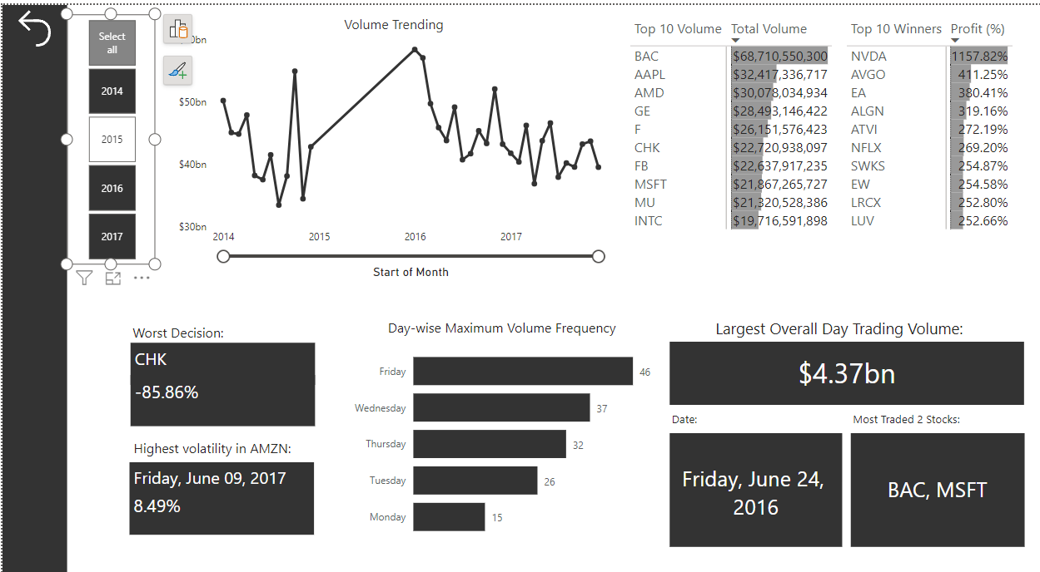



## Report View

### Volume Analysis by Date Page

### Close Prices Analysis Page

